RECTIFIER:0-600V 0- 20A ( Optional selector )
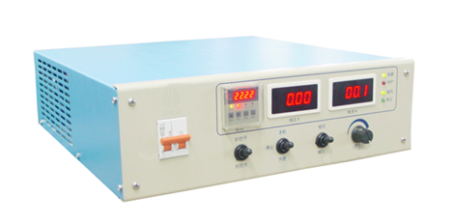

Panel Configuration：

- Timer 2.Voltmeter 3、Ampere meter 4. Function Indicator lights 5、Output current and voltage adjust 6、CC/CV selective switch 7、START/STOP switch 8、Timer ON/OFF 9、Power switch

Index parameters:
1) Input voltage range: 380VAC (three phase)
2) Output current stability: ≤2%
3) Output voltage stability: ≤1%
4) Efficiency: ≥85%
5) Power factor: ≥0.9
6) Start-up postponing time: ≤10s
7) Inverting frequency: 18kHz ± 2kHz
8) Current limiting value: Io + 10A - 50A (Io is the rated current)
9) Voltage limiting value: 1.01 - 1.03Vo (Vo is the rated voltage)
10) Cooling mode: air cooing
11) Time delay adjust (optional)
Product features:
1) Small size, light weight, high efficiency, high control precision.
2) Smooth wave form low ripple current output, Suitable for plating small sized no-ferrous metal and alloy work pieces, it has high penetration ability, strong adhesive force, and can effectively enhance the brightness of the plated surface.
3) Output voltage and current can be adjusted, limiting voltage and current can be adjusted, greatly enhance application flexibility of the product for users.
4) With complete protection functions, over current, overheat protection functions. High power factor, less pollution to the electric network, no interference

Scope of application:
It is suitable for EDI water process , acidic copper, alkaline copper, multi-layer nickel, Chrome ，zinc , gold ,silver , indium，rhodium, electrolysis degreasing ,and single or double-clad plated printing process.

