HIGH FREQUENCY RECTIFIER
Output : 0-200A, 0-15V ( optional selection )

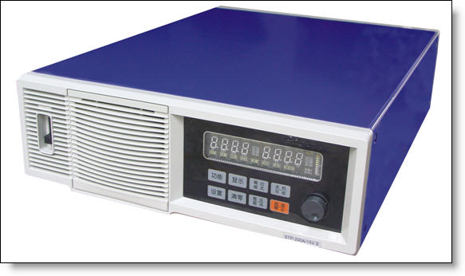

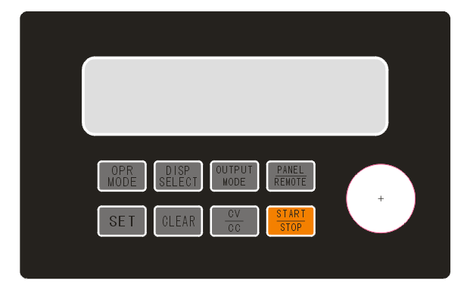

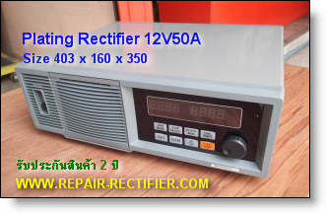
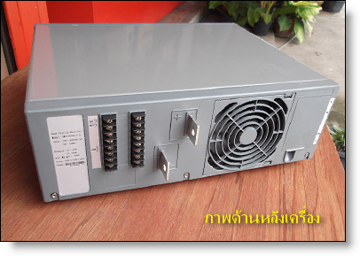

Specification:
1) Input voltage range: 1 Phase 220VAC+-10%
2) Output current stability: ≤2%
3) Output voltage stability: ≤1%
4) Efficiency: ≥85%
5) Ripple≤3%
6) Start-up postponing time: ≤10s
7) Current limiting value: Io + 10A - 50A (Io is the rated current)
8) Voltage limiting value: 1.01 - 1.03Vo (Vo is the rated voltage)
9) Cooling mode: air cooling

Product features:
1) Small size, light weight, high efficiency, high control precision.
2) Suitable for different kinds of work pieces, it has high penetration ability, strong adhesive force, and can effectively enhance the brightness of the plated surface.
3) Output voltage and current can be adjusted, limiting voltage and current can be adjusted, greatly enhance application flexibility of the product for users.
4) With complete protection functions, over current, overheat protection functions. High power factor, less pollution to the electric network, no interference
5)Proper measures are taken to prevent salt mist and acid corrosion so as to prolong the service life of the product under extreme application enviroment.
Scope of application:
It is suitable for acidic copper, alkaline copper, multi-layer nickel, Chrome ，Aluminum ,zinc , gold ,silver , indium，rhodium, electrolysis degreasing ,and single or double-clad plated printing process.

