Rectifier: STM0-1500amp/0-15volt
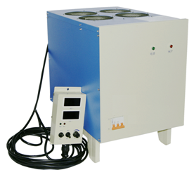

Panel Configuration：

- Power indicator light 2、Protection indicator light 3、Power switch 4、AC power cable，5、Output anode copper bar 6、Output cathode copper bar 7、Earth screw

Remote control box configuration：
1、Digital voltmeter
2、Digital ampere meter
3、Protection alarm indicator light
4、Timer On/OFF
5、Output current and voltage adjust
6、CC/CV selective switch
7、Start/Stop switch
8、Timer
9、Power light
Specification:
1) Input voltage range: 3 Phase 380VAC (350VAC-450VAC)
2) Output current stability: ≤2%
3) Output voltage stability: ≤1%
4) Efficiency: ≥88%
5) Power factor: ≥0.9
6) Start-up postponing time: ≤10s
7) Inverting frequency: 18kHz ± 2kHz
8) Current limiting value: Io + 10A - 50A (Io is the rated current)
9) Voltage limiting value: 1.01 - 1.03Vo (Vo is the rated voltage)
10) Cooling mode: air cooing
Product features:
1) Small size, light weight, high efficiency, high control precision.
2) High frequency pulsant wave form current output, Suitable for different kinds of work pieces, it has high penetration ability, strong adhesive force, and can effectively enhance the brightness of the plated surface.
3) Output voltage and current can be adjusted, limiting voltage and current can be adjustable, greatly enhance application flexibility of the product for users.
4) With complete protection functions, over current, overheat protection functions. High power factor, less pollution to the electric network, no interference

Scope of application:
It is suitable for acidic copper, alkaline copper, multi-layer nickel,decorating Chrome ，Aluminum ,zinc , gold ,silver , indium，rhodium, electrophoresis,electrolysis degreasing ,and single or double-clad plated printing process.

